Unit 2 Progress Check – College Board Questions
- Which statement is true about the circular flow diagram of an economy?
- The market for goods and services connects household spending to government spending.
- The market for factors of production connects household spending to goods produced by firms.
- The market for factors of production connects spending by firms to household income.
- The market for goods and services connects labor income to firms as employers.
- The market for goods and services connects labor income to household spending.
- Which statement is true about the approaches used to measure the value of a nation’s gross domestic product (GDP) ?
- The expenditure approach to calculating GDP sums the components of the supply side of the economy.
- The income approach to calculating GDP sums the income earned by the factors of production excluding profits.
- The value-added approach to calculating GDP sums the final monetary value of output at each stage of production.
- The expenditure approach to calculating GDP sums the market value of all final goods and services produced by foreigners in a given period of time.
- The expenditure approach to calculating GDP sums consumption spending, investment spending, government spending, and net exports.
- Calculate Country X’s nominal gross domestic product (GDP) for 2017 using the expenditures approach.
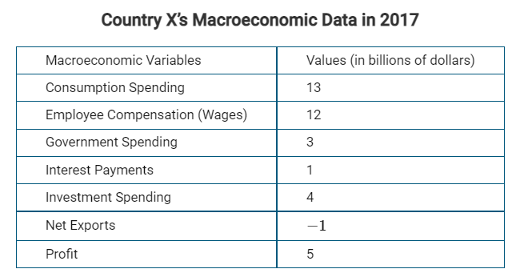
- 14 billion dollars
- 18 billion dollars
- 19 billion dollars
- 20 billion dollars
- 21 billion dollars
- Which of the following describes a limitation of gross domestic product (GDP) ?
- It overstates the value of output by counting non-market transactions such as mowing your neighbor’s lawn.
- It understates the value of output by accounting for negative environmental side effects of production.
- It does not account for the distribution of income in a nation or income inequality.
- It overstates economic well-being by including all do-it-yourself activities.
- It fails to make adjustments for the value of services consumed for free such as browsing on the Web.
- Which of the following is true about gross domestic product (GDP) ?
- Calculations of GDP include the monetary value of non-market production activities such as households preparing own meals at home.
- Calculations of GDP do not include the monetary value of production activities involving negative environmental side effects such as pollution.
- Calculations of GDP include the monetary value of illegal production activities such as drug cartels.
- Calculations of GDP include the sale of used goods.
- Calculations of GDP include the unsold inventories of goods produced within the borders of the country.
- As a measure of economic performance, the United States gross domestic product (GDP) accounts for which of the following?
- The use of open-source, free Web browsers
- A parent’s care of children in the home
- The street sale of illegal substances
- The cleanup of an oil spill
- The production of vegetables grown in the backyard and consumed by the family
- Which of the following is classified as a discouraged worker?
- Javier earned a degree in business and is actively seeking a job in the financial sector.
- Sara has been unable to find a job and abandoned her job search.
- Raphael decided to be a stay-at-home dad after he lost his job.
- Ida was laid off during a downturn in the economy and is looking for a new job.
- Zack volunteers at the local elementary school all year long.
- What type of unemployment describes the situation of factory workers displaced by automation?
- Cyclical
- Frictional
- Natural
- Seasonal
- Structural
- Given the labor market data above, what are the labor-force participation rate (LFPR) and the unemployment rate (UR) ?
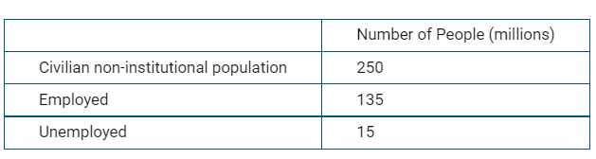
- The LFPR is 60% and the UR is 6.0%.
- The LFPR is 54% and the UR is 6.0%.
- The LFPR is 54% and the UR is 10.0%.
- The LFPR is 60% and the UR is 10.0%.
- The LFPR is 60% and the UR is 3.3%.
- Suppose the consumer price index (CPI) was 100 on January 1st, 2017 and 110 on January 1st, 2018 with no changes in nominal wages. Which of the following is definitely true about the economy between January of 2017 and January of 2018?
- The inflation rate was 10 percent.
- The inflation rate was −10 percent.
- Real wages increased by 10 percent.
- There was disinflation of 10%
- Nominal GDP decreased by 10 percent.
- Jan works a 30-hour week for a minimum wage of $10 an hour. Suppose that last year is the base year for the Consumer Price Index (CPI) . Which of the following is true about Jan’s real wage if at the end of this year the CPI is 125 ?
- Jan’s real wage at the end of this year is $10 an hour because the base year equals 100.
- Jan’s real wage is $2.50 per hour at the end of the year due to inflation.
- Jan’s real wage is 25% higher because the CPI increased from 100 to 125.
- Jan's real wages are equal to the nominal wages.
- Jan’s real wage is $8 per hour at the end of the year.
- Which of the following terms describes a slowdown in the rate of increase in the consumer price index?
- Deflation
- Disinflation
- Hyperinflation
- Inflation
- Stagflation
- Last year, Myron purchased a $10,000 certificate of deposit with a 3% rate of interest from his bank. The government reported that prices, on average, have fallen by 5% during the current year. Which of the following can be concluded as a result of this transaction?
- Myron loses, while the bank gains.
- Myron gains, while the bank remains unaffected.
- Myron gains, while the bank loses.
- Both Myron and the bank equally gain.
- The bank gains, while Myron remains unaffected.
- Which of the following will happen when the actual inflation rate exceeds the expected inflation rate?
- This will benefit lenders with fixed-interest rate loans.
- This will harm lenders with variable-interest rate loans.
- This will harm lenders with fixed-interest rate loans.
- This will harm borrowers with fixed-interest rate loans.
- This will benefit borrowers with variable-interest rate loans.
- Labor unions negotiated a 3-year contract with employers in the automobile industry. They agreed to a 3 percent per year increase in pay over the 3 years. How would each group be affected by an actual inflation rate of 4% next year?
- Workers would be better off, and the employers would be worse off.
- Workers would be better off, and the employers would be unaffected.
- Workers and employers would be equally well off.
- Workers would be worse off, and the employers would be unaffected.
- Workers would be worse off, and the employers would be better off.

- Which of the following describes a difference between nominal gross domestic product (GDP) and real GDP ?
- Nominal GDP uses constant prices to measure the value of final output, while real GDP uses current prices.
- Nominal GDP uses current prices to measure the value of final output, while real GDP uses constant prices.
- Nominal GDP measures how much output is produced within the borders of a country, while real GDP measures how much output is produced around the world by domestic companies.
- Nominal GDP includes sales of used goods while real GDP does not.
- Nominal GDP takes into account the size of the population while real GDP does not.
- Which of the following is the correct calculation of Real Gross Domestic Product (GDP) ?
- RealGDP=NominalGDP/GDPdeflator x 100
- RealGDP=GDP deflator/NominalGDP / 100
- RealGDP=NominalGDP×GDPdeflator x 100
- RealGDP=NominalGDP + GDPdeflator -100
- RealGDP=Nominal GDP−GDPdeflator + 100
- Suppose Miguel wants to know the value of real gross domestic product (GDP) for 2011 in terms of the base year 1984 dollars. In 1984 nominal GDP was $10 billion. In 2011 nominal GDP was $15 billion and the price deflator was 200. Real GDP 2011 in 1984 dollars would be equal to which of the following?
- $5 billion
- $7.5 billion
- $10 billion
- $20 billion
- $30 billion
- The output gap is measured by which of the following?
- The difference between nominal and real GDP .
- The difference between actual and potential GDP .
- The difference between the expenditure side of GDP and the income side of GDP .
- The difference between the actual rate of unemployment and the natural rate of unemployment.
- The difference between the GDP deflator and the consumer price index in a given year.
- The economy of Fisherland is at full employment for which year in the above diagram?
- 2009
- 2010
- 2013
- 2015
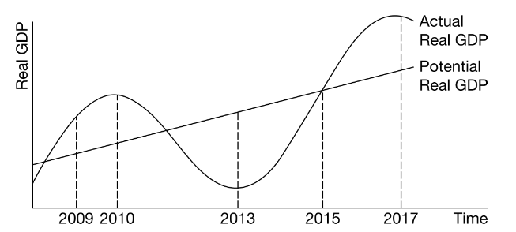
- 2017
- When an economy is at the trough of the business cycle, which of the following is then true about the state of the economy?
- There is a recessionary gap.
- There is an inflationary gap.
- The economy is producing at its potential output level.
- The economy is producing above its potential output level.
- The unemployment rate is lower than the natural rate of unemployment.

ANSWERS
1 | C | 11 | E
2 | E | 12 | B
3 | C | 13 | C
4 | C | 14 | C
5 | E | 15 | E
6 | D | 16 | B
7 | B | 17 | A
8 | E | 18 | B
9 | D | 19 | B
10 | A | 20 | D
 |  | 21 | A

